Newark Vol. Fire Department
  - Application for membership
An application with this Department does not make you a member. This application will be reviewed by the department during the regular business meeting held on the first Monday of every month at 7pm at the fire station. You must be present at the time of the meeting to be considered for membership. Your application will be read out loud to the dept. at which time they have the right to ask you any questions. You will be asked to leave as we review your application. A motion and a second to accept your application will be required, then you must receive a majority vote to be approved. The Asst Chief will notify you of the department’s decision. If approved there will be a 90 day probation for evaluation purposes and training. The Department has the right to deny membership at any time for any reason. The Chief has the right to deny any application that he believes is not for the good of the Department. Thanks for your application!
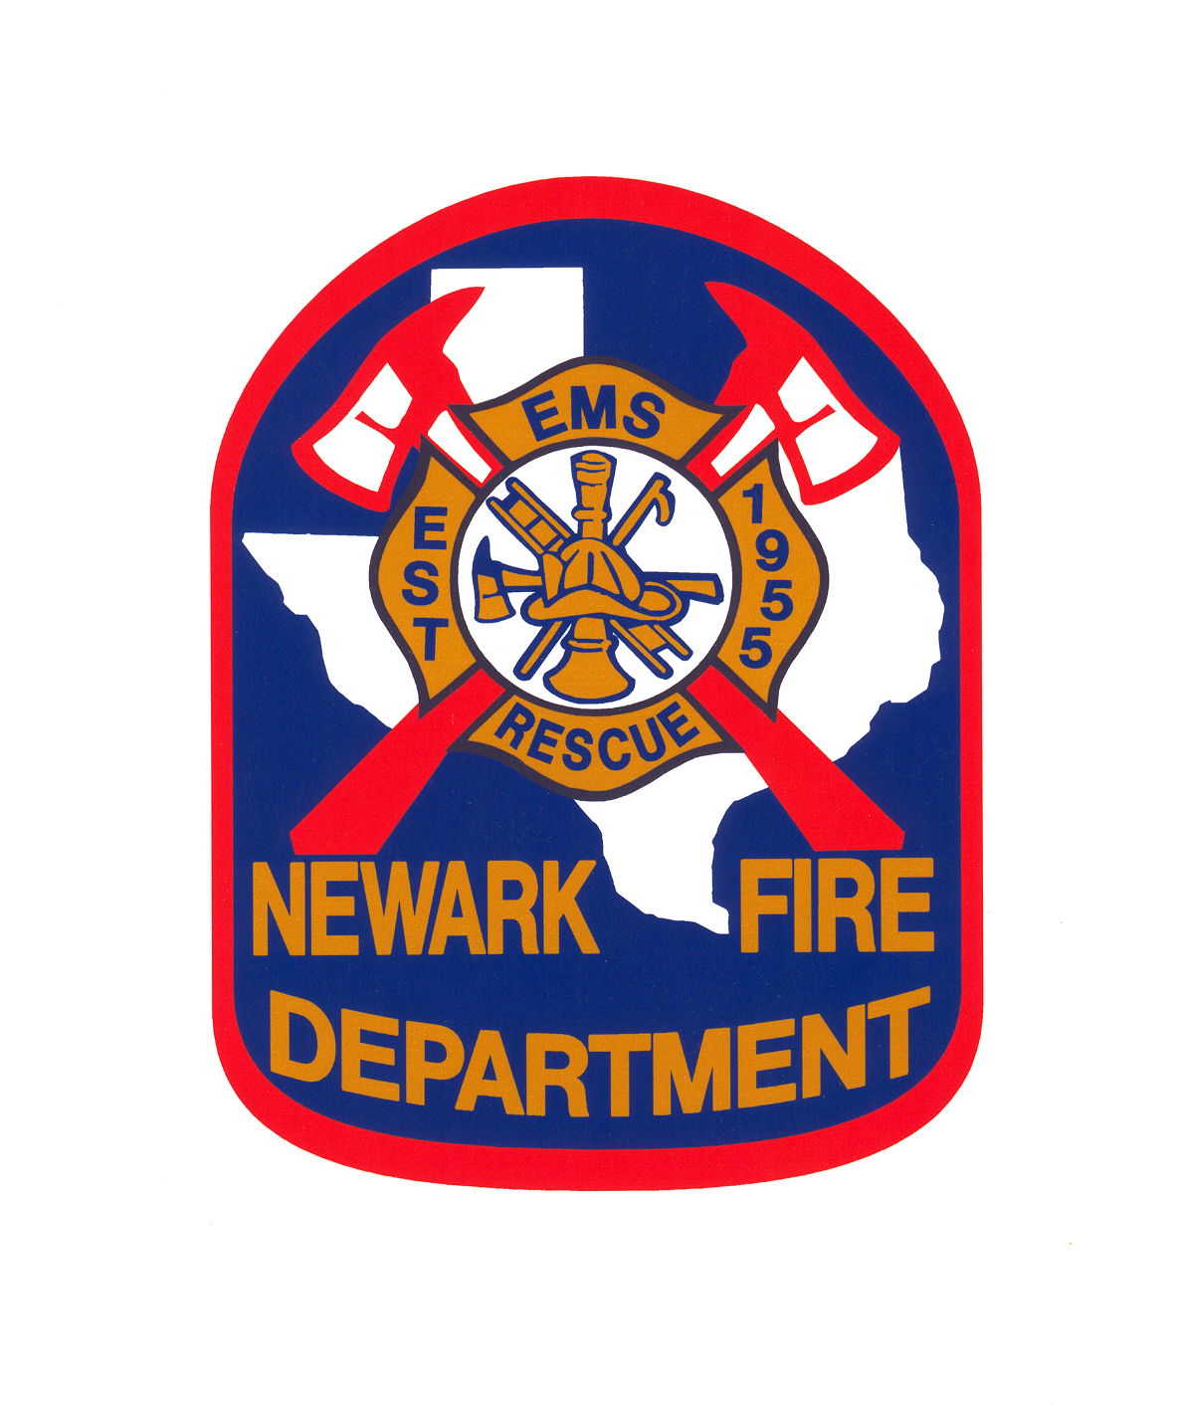
Date______/_______/_______ Date accepted____/____/________
Prob. End date____/____/________

Full Legal Name______________________________________________________
Address____________________________________________________________
City__________________________State_____________Zip__________________
Phone________________Cell___________________SS#_____________________
Texas DL#_______________________Class___________Exp__________________
DOB_______________Marital Status M S D W No. of children________
Emergency Contact___________________________#_______________________

Medical conditions that we need to be aware of: _________________________________________________________________________________________________________________________________________________________________________________________________________
Have you ever had a back, neck or knee injury? Y / N
Have you ever been examined or treated for a mental disorder? Y / N
Do you have any allergies that could interfere with any calls? Y / N
Please list: ( example: grass, cats or smoke )_______________________________
___________________________________________________________________
Allergies to medicine__________________________________________________

Please list all residences you have lived at in the last five years.
1._________________________________________________________
2._________________________________________________________
3._________________________________________________________
Do you understand the risk involved in firefighting? Y / N
Do you understand that everything you do will be volunteer? Y / N
Have you had any past experience with firefighting or been a part of a Volunteer Dept.? If yes, please list.

Dept._______________________________State______________YRS_________

Dept._______________________________State______________YRS_________

Dept._______________________________State______________YRS_________
Please list any Fire or Ems certifications and exp. dates.
__________________________________________________________________
__________________________________________________________________
Please list any other Fire or Ems training you might want us to know about.
__________________________________________________________________
__________________________________________________________________
Are you a current member of SFFMA? Y / N

Current employer____________________________________________________
Employer’s address___________________________________________________
City, State and Zip____________________________________________________
Phone #________________________Supervisor___________________________
How long at current job?_______________
If at current job less than 5 years, please list your previous employer.
___________________________________________________________________

Education:
High School Name:____________________________Graduate Y / N
College______________________________________Major__________________
Other_________________________________________________________________________________________________________________________________
___________________________________________________________________

If you did not graduate, do you have a GED? Y / N

Have you ever been arrested or questioned for a crime? Y / N
If yes please explain__________________________________________________
___________________________________________________________________
___________________________________________________________________
Have you ever been convicted of a misdemeanor crime? Y / N
If yes please explain__________________________________________________
___________________________________________________________________
___________________________________________________________________
Have you ever been convicted of a felony? Y / N
If yes please explain__________________________________________________
___________________________________________________________________
___________________________________________________________________
Please list three people not related to you for reference:
Name__________________________________Phone #_____________________
Name__________________________________Phone #_____________________
Name__________________________________Phone #_____________________
Please List two members of Newark Fire Department for reference: ( Optional )
Name______________________________________________________________
Name______________________________________________________________

I attest that all information given on this application is true and correct to the best of my knowledge. I understand that misrepresentation or omission of the facts would be cause for dismissal. Further. I understand and agree that my membership is for no definite period and may be terminated at any time without notice. I also authorize a full investigation of all statement contained in this application and that individuals and companies are released to give out any information requested. I also authorize Newark Fire Dept. to complete a full criminal and driving back ground check.
Accident Waiver
I hereby release Newark Fire Dept. from responsibility of any and all accidents that may occur while performing duties assigned to me. In the case I should be hurt, I do hereby relinquish my rights to sue the Newark Fire Dept. for damages. I understand that Newark Fire Dept. carries workers comp insurance. And that if I fail to make a report on the date of the incident that this could delay payments for treatment and could even cause possible denial of the claim.

Signed________________________________________Date_________

STATE OF______________________
COUNTY OF____________________
BEFORE ME, the undersigned a notary public in and for said County and State did appear______________________, Known to me to be the person whose name is subscribed to the foregoing instrument.
GIVEN UNDER MY HAND AND SEAL OF OFFICE this__________day of
________________20_____.

________________________________
Notary Public

